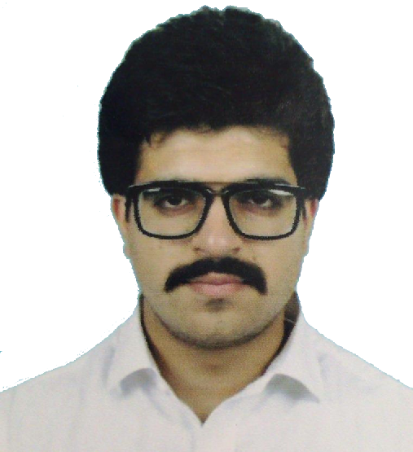
PERSONAL STATEMENT
I am highly driven toward solutions and success, and enjoy bringing others with me on the journey. I can apply my best in the field of business ethics and to contribute in progress of the organization in same fashion using my technical skills. Experiences from company have given me an insight into various aspects of company developments which has widened my perspective and given me a sense of understanding of my work from a practical point of view. I am able to efficiently multi-task, maintaining control over many projects simultaneously and tend to take on challenging assignments or difficult tasks with successful completion. Socially poised and confident able to speak in a persuasive way to both small and large groups of people & have a strong ability to motivate and manage others through my firm delegation of tasks.

Amir Tariq Ahmed
Mechanical Engineer
+91-8308866111

CAREER OBJECTIVE
TECHNICAL SKILLS
Good Hands on MS OFFICE
O.S Environment: XP, W7,W8 & MAC
I am goal driven, especially financial goals and to work in a competitive environment on challenging assignments that shall fosters creativity, continual learning and yield the twin benefits of the job satisfaction and a steady paced professional growth.

KEY SKILLS
EXTRA-CURRICULAR
*Workshop on Aptitude Development-2011
* Tree Plantation in-2011
* Participated in seminar of Islam against terrorism in 2009.
*Participated in various seminar on Thermal Power Plant

- I am highly productive.
- I am highly driven by competition, challenges, and economic incentives.
- I will protect organizational or team finances, as well as my own.
- I am profit driven and bottom-line oriented.
- I am able to multi-task in a variety of areas, and keep important projects moving.

EDUCATION
HOBBIES

QUALIFICATION | BOARD/ UNIVERSITY | YEAR OF PASSING | PERCENTAGE | DIVISION
B.E. Mech. Engg. | Nagpur University | 2014 | 64.10 | FIRST
H.S.S.C | Nagpur Division | 2009 | 62.67 | FIRST
S.S.C | Nagpur Division | 2007 | 73.07 | FIRST
*Swimming,
*Gymming,
*Adventure Sports

WORKING PROJECT
PERSONAL DOSSIER
WORKING PROJECTS

Design And Development Of Mechanically Automated Renovative Under Transforming Intelligence.
- A controlling system is implemented for a wearable walking supporting device so called as Mechanically Automated Renovative Under Transforming Intelligence (MARUTI). The control circuit is implemented without considering the biological signals of the human body for the knee part, which is based on the knee joint moment from the human body model. The control and a driving circuits are implemented to assistive the knee as for the requirement of knee joint dynamics.
- Published a paper in INTERNATIONAL JOURNAL OF TECHNOLOGY ENHANCEMENTS AND EMERGING ENGINEERING RESEARCH, VOL 2, ISSUE 4 31 ISSN 2347-4289

Date of Birth : 25th Nov. 1991
Address : Plot no 2, Aradhna society,
opp tidke vidyalya school,
katol road, Nagpur 440013
Sex : Male
Nationality : Indian
Marital Status : Single

Email : mohammedaamir.ahmed@yahoo.com

PROFESSIONAL EXPERIENCE
Work experience of One Year
As a Senior Executive:
Working in reliance power VIPL 2*300 MW as an executive trainee in Ash Handling Plant Maintenance Department.
Deputed in Ash Handling Plant Maintenance Department.
1. Performed breakdown and preventive maintenance at AHP(Bottom Ash Hoppers Section, Silo Area and HCSD system and complete ESP Hoppers Section).
2. Supervised the complete overhauling of AHP system(Bottom Ash Hoppers, ESP Hoppers and Silo Area).
3. Analyzed the mandatory spare parts of each equipment to facilitate the activities during routine or breakdown maintenance.
4. Learned about complete AHP system which includes (Bottom Ash Hoppers, Silo and HCSD system, ESP Hoppers, Compressor Room, Nuva Feeders).
5. Performed codification work for required mandatory spare parts.
WORK EXPERIENCE
I hereby declare that the above information is correct to the best of my knowledge and I bear the full responsibility for the correctness of the above mentioned particulars.

DECLARATION

